COVID-19 NOTICE
SAFETY UPDATE

PLEASE PRACTICE SOCIAL DISTANCING

As part of an ongoing statewide effort to prevent the spread of COVID-19, Georgia State Parks strongly encourages guests to practice social distancing and follow guidelines for hygiene while visiting the parks. This applies to our Park Rangers as well.

Park Day Use Areas are OPEN and available for Park Visitors to enjoy. While visiting the beach, Park Staff will encourage all visitors:
- To maintain a 6’ social distance between all visitors and staff.
- There should be no groups of more than 10 people.
- Visitors are encouraged to wash hands and/or use hand sanitizer frequently.
- Visitors are encouraged to wear cloth face coverings in all public settings.

Park Passes are available for purchase in our self-serve kiosks (Iron Rangers) throughout the park. For electronic payment, using your smartphone, scan this QR code to purchase a day use ParkPass for your vehicle using a credit card.

Reservations: 1-800-864-7275 or https://gastateparks.org/Reservations

For the latest updates on park status visit: gastateparks.org/Alerts

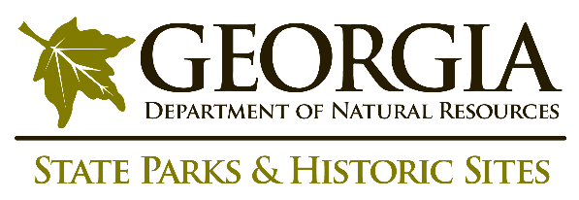
The safety and welfare of staff and the public is a top priority for the Georgia Department of Natural Resources, as we continue to monitor COVID-19 guidance from the Center for Disease Control and Prevention.
FOR IMMEDIATE EMERGENCY ASSISTANCE PLEASE DIAL 911

